1. **Arduino UNO platform ------- Tracking**
2. **Preparation**

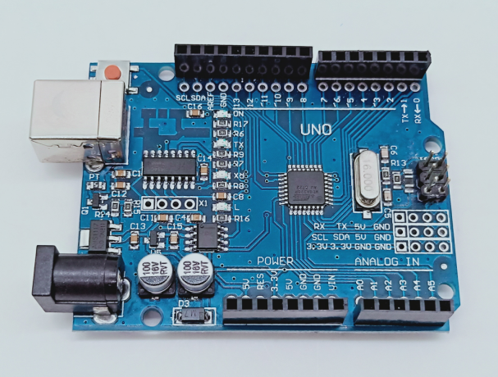

1-1 Arduino UNO board

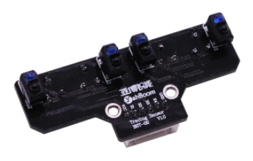

1-2 Infrared patrol module

**2)Purpose of Experimental**

After the code upload is completed, you need to press the K2 to start the car, and the tracking function is started. The robot car will automatically walk along the black line.

**3)Principle of experimental**

The basic principle of the infrared tracking sensor is to take advantage of the reflective nature of the object. In this experiment, we need the effect that the robot car walk along the black line. When the infrared light is emitted onto the black line, it will be absorbed by the black line, but when the infrared light is emitted onto the other colors line, it will be reflected onto the infrared receiver pin. According to this, we write the corresponding code to make the car complete tracking function.

When the car detects the black line, the indicator status of the infrared tracking module is as shown in the figure below.

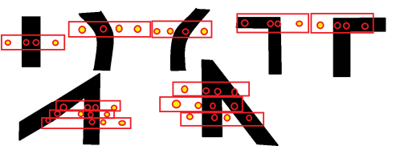

**4)Experimental Steps**

4-1 About the schematic

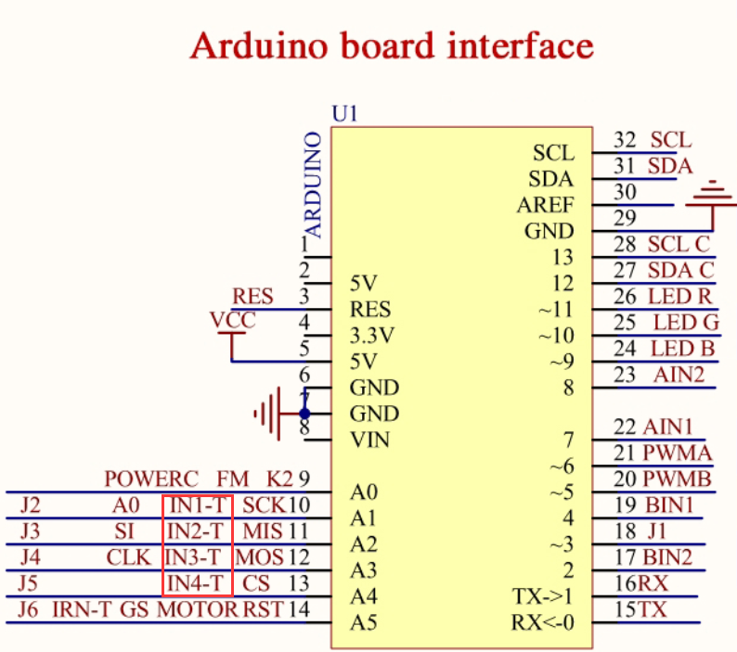

4-1 Arduino UNO interface circuit diagram

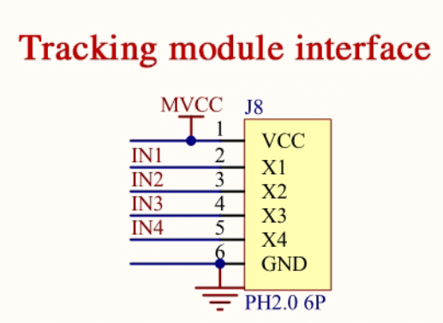

4-2 Tracking module interface

4-2 According to the circuit schematic:

Left1 infrared sensor-----A2(Arduino UNO)

Left2 infrared sensor-----A1(Arduino UNO)

Right1 infrared sensor-----A3(Arduino UNO)

Right2 infrared sensor-----A4(Arduino UNO)

Note1: In this experiment, you need to connect X1, X2, X3, X4 on the expansion board by jumper caps, as shown below.

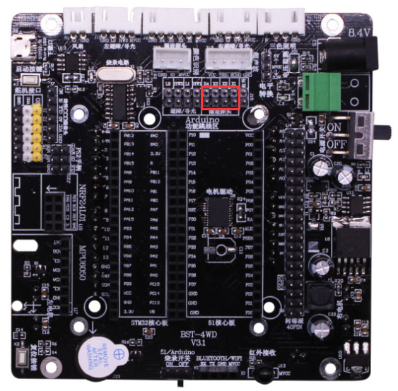

Note2: In this experiment, we can adjust the sensitivity of the tracking module by rotating the potentiometer of the infrared tracking module to achieve better experimental results.

4-3 About the code

1. We need to open the code of this experiment:**tracking.ino**, click“**√**” under the menu bar to compile the code, and wait for the word "**Done compiling** " in the lower right corner, as shown in the figure below.

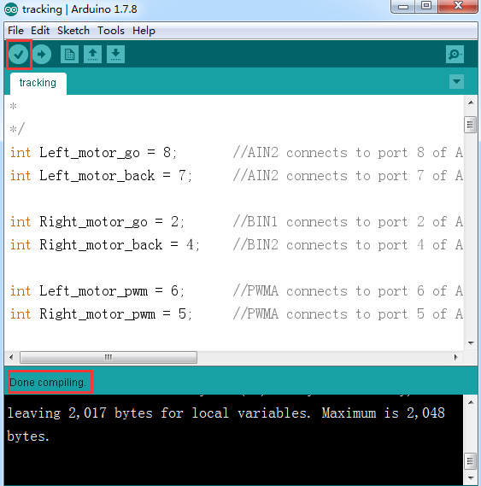

2.In the menu bar of Arduino IDE, we need to select 【Tools】---【Port】--- selecting the port that the serial number displayed by the device manager just now, as shown in the figure below.

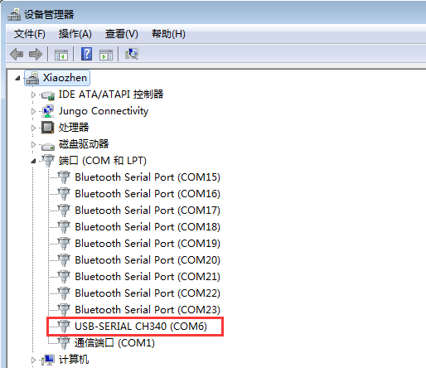

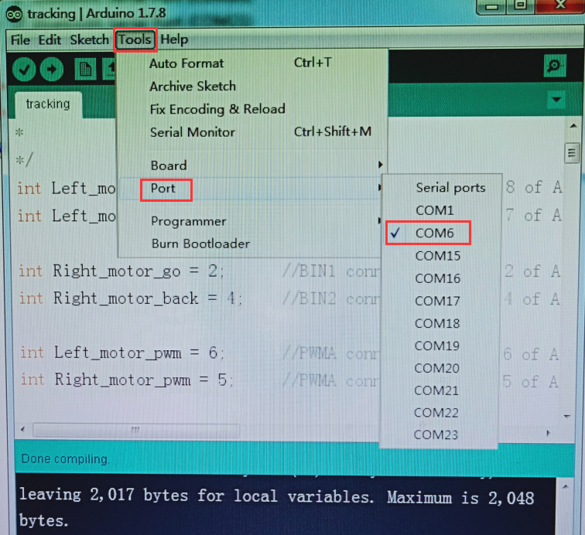

3.After the selection is completed, you need to click “**→**”under the menu bar to upload the code to the Arduino UNO board. When the word “**Done uploading**” appears in the lower left corner, the code has been successfully uploaded to the Arduino UNO board, as shown in the figure below.

